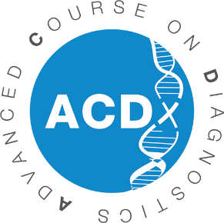

11th Advanced Course on Diagnostics (ACDx)
Application Form
September 18-23, 2022 - Les Pensières Center for Global Health

To apply as a participant to the Advanced Course on Diagnostics which will be held in Les Pensières Center for Global Health, 55 route d’Annecy, Veyrier-du-Lac (France) in September 18-23, 2022, we ask you to provide the following information and to send it back to: sandra.angele@fondation-merieux.org. Thank you.

PERSONAL DETAILS
GENDER
FIRST NAME
LAST NAME
DATE OF BIRTH
NATIONALITY
POSITION
INSTITUTION/COMPANY
ADDRESS
POST CODE
CITY
COUNTRY
WORK PHONE
MOBILE PHONE
SKILLS
SHORT BIOGRAPHY
HOW DID YOU HEAR ABOUT ACDX?
FLUENCY IN ENGLISH
FEES CHARGED TO
EMAIL
EDUCATION
UNIVERSITY/SCHOOL  (NAME AND CITY) | FROM | UNTIL | FIELD OF STUDY | DEGREE

PROFESSIONAL EXPERIENCE
NAME OF INSTITUTION/COMPANY | FROM | UNTIL | ROLE/POSITION

EXPERIENCE IN DIAGNOSTICS

EXPECTED IMPACT & MOTIVATION

PLEASE PROVIDE A LETTER OF RECOMMENDATION FROM SUPERVISOR

