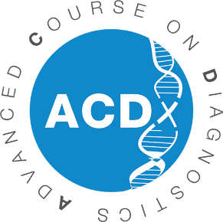

13th Advanced Course on Diagnostics (ACDx)
Application Form
September 15-20, 2024
Les Pensières Center for Global Health – 55, route d’Annecy, Veyrier-du-Lac (France)

To apply as a participant to the Advanced Course on Diagnostics, please provide the following information and send it back to: sandra.angele@fondation-merieux.org before April 30, 2024.
Thank you.

PERSONAL DETAILS
GENDER
FIRST NAME
LAST NAME
DATE OF BIRTH
NATIONALITY
POSITION
INSTITUTION/COMPANY
ADDRESS
POST CODE
CITY
COUNTRY
WORK PHONE
MOBILE PHONE
SKILLS
SHORT BIOGRAPHY
HOW DID YOU HEAR ABOUT ACDX?
FLUENCY IN ENGLISH
FEES CHARGED TO
EMAIL

EDUCATION
UNIVERSITY/SCHOOL  (NAME AND CITY) | FROM | UNTIL | FIELD OF STUDY | DEGREE

PROFESSIONAL EXPERIENCE
NAME OF INSTITUTION/COMPANY | FROM | UNTIL | ROLE/POSITION

EXPERIENCE IN DIAGNOSTICS

EXPECTED IMPACT & MOTIVATION

By submitting your application, your data will be processed to handle your inscription and send you communication about Fondation Mérieux’s projects. You can unsubscribe by using the link provided into our emails. Depending on the event, your data may be transfer to organizers that could be located outside European Union.
Your email address may be shared in the context of the course with other participants. If you disagree, please inform sandra.angele@fondation-merieux.org.
Please visit our Privacy Policy for more information including about your rights.

