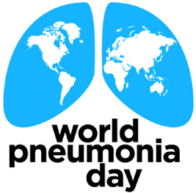
MÉRIEUX FOUNDATION & EVERY BREATH COUNTS
World Pneumonia Day 2022
Small Grants Awards call for proposals
Proposals should be submitted by June 23, 2022, to Valentina PICOT:
valentina.picot@fondation-merieux.org

PROJECT TITLE
HOSTING ORGANIZATION
COUNTRIES OF INTERVENTION
BACKGROUND
ACTIVITY DESCRIPTION
DATE OF ACTIVITY / DURATION
OBJECTIVES
TARGET AUDIENCE / BENEFICIARIES
LOCAL PARTNERS / GLOBAL PARTNERS
EXPECTED IMPACT & OUTCOMES
BUDGET
FOCAL POINT OF CONTACT
REFERENCES (IF APPLICABLE)

