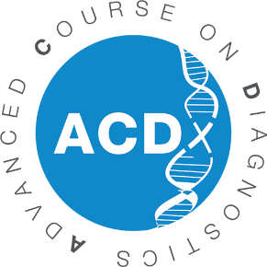

12th Advanced Course on Diagnostics (ACDx)
Application Form
September 17-22, 2023
Les Pensières Center for Global Health – 55, route d’Annecy, Veyrier-du-Lac (France)

To apply as a participant to the Advanced Course on Diagnostics (ACDx), please complete the following application form and send it to: sandra.angele@fondation-merieux.org.

Thank you.

PERSONAL DETAILS
GENDER
FIRST NAME
LAST NAME
DATE OF BIRTH
NATIONALITY
POSITION
INSTITUTION/COMPANY
ADDRESS
POST CODE
CITY
COUNTRY
WORK PHONE
MOBILE PHONE
SKILLS
SHORT BIOGRAPHY
HOW DID YOU HEAR ABOUT ACDX?
FLUENCY IN ENGLISH
FEES CHARGED TO
EMAIL

EDUCATION
UNIVERSITY/SCHOOL  (NAME AND CITY) | FROM | UNTIL | FIELD OF STUDY | DEGREE

PROFESSIONAL EXPERIENCE
NAME OF INSTITUTION/COMPANY | FROM | UNTIL | ROLE/POSITION

EXPERIENCE IN DIAGNOSTICS

EXPECTED IMPACT & MOTIVATION

